Week 7 Homework
Hash Map
By Lauren Geislinger
10/10/2020

I was able to do a Hash Map for the week 6 in class assignment, so I just reused my work for this assignment. I used the time measurement method I had been using for other projects.
Instant starts = Instant.now();
Thread.sleep(10);
Instant ends = Instant.now();

System.out.println(Duration.between(starts, ends));

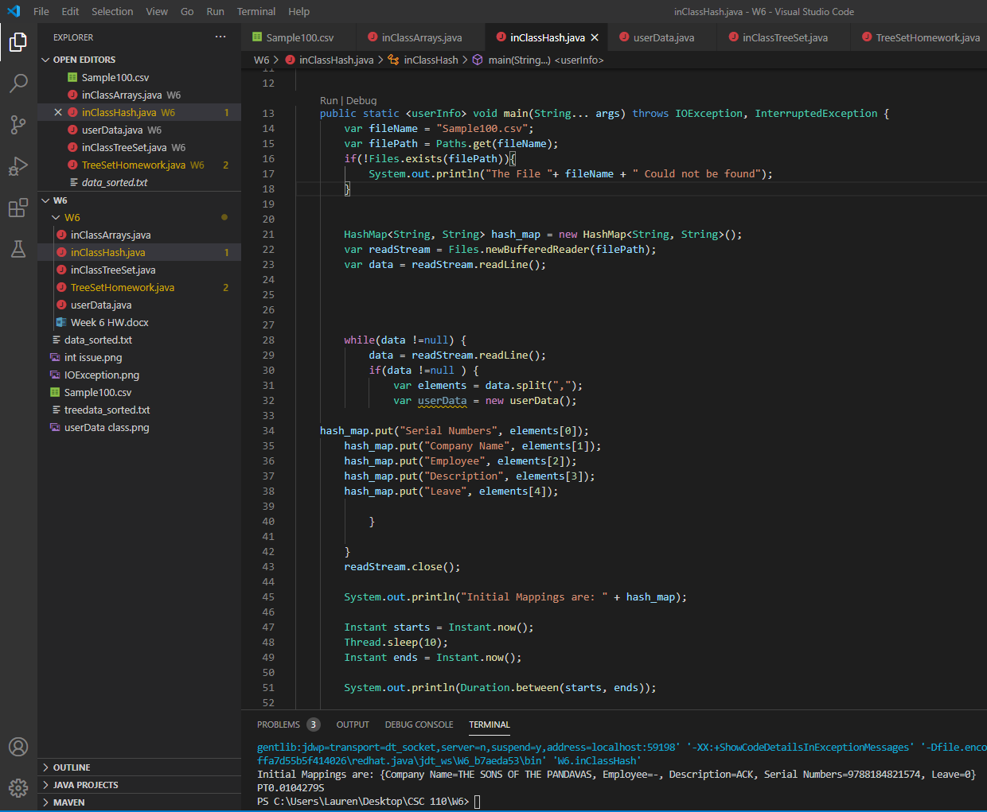

I got a time reading of PT0.0104279S for the Hash Map.

The second part of this homework asked to run and compare time output for the Hash map and Tree Set.
I chose to run the Tree Set done in class last week.
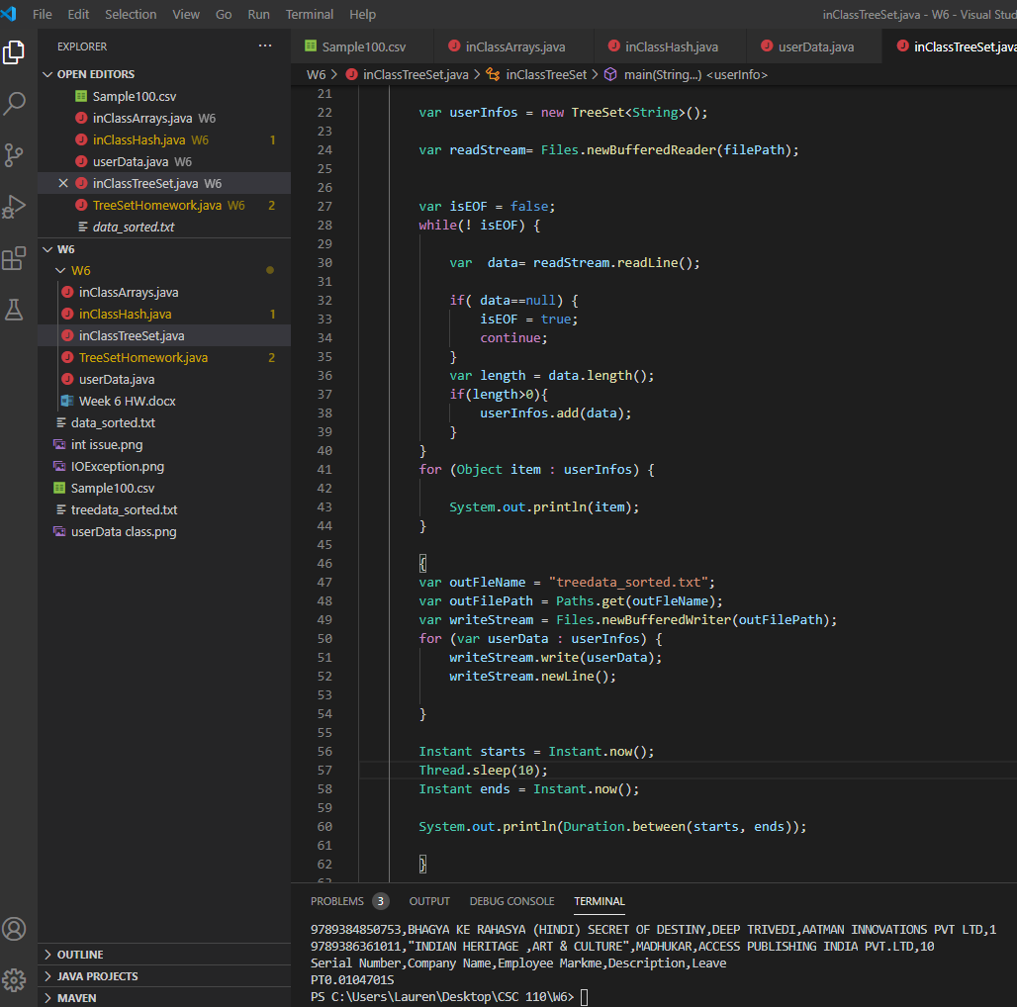
The time reading for the Treeset was PT0.0104701S.
The run time is very close for both. I think it is amazing that you can compile and run the same code any number of times and get a different time output each time.

